BAD SHERMAN
Watch Anish + MB&F + L’Epée 1839
Exclusive to WatchAnish.com
You know who we like? Who’s a real mensch? Sherman from MB&F. He’s a decent kinda fella, affable, reliable, like clockwork. You could trust him to be polite to your mother in law, or water your plants while you’re on vacation. He’s an all round good guy. You can take him anywhere, well, anywhere respectable.
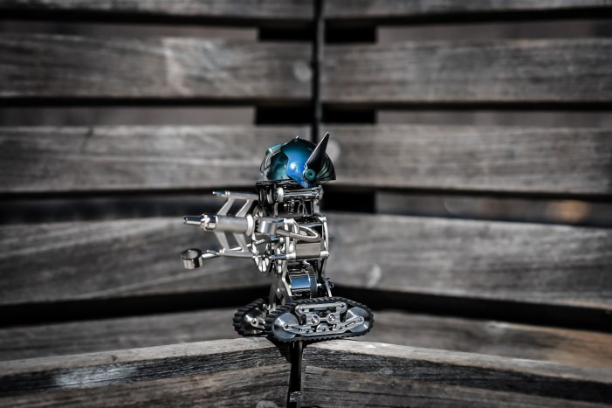
But there are places you wouldn’t take him. Places that might shock him. Places like Vegas, or Bangkok, or all night shooting ranges in Kyrgyzstan where they’ll let you blow up a 1994 Honda Accord using a Soviet grenade launcher. Those kind of places are not for Sherman, which is a damn shame, because Anish loves those kind of places.
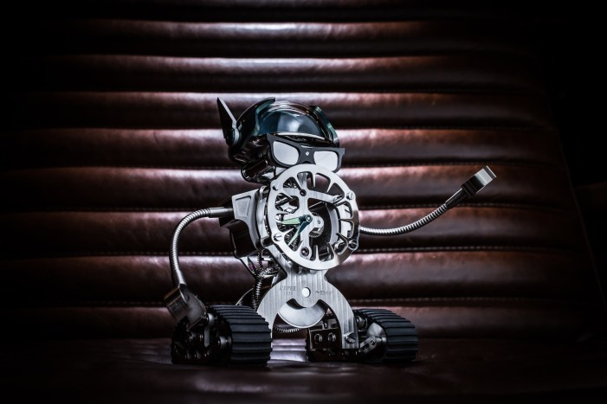
Luckily though, the guys at MB&F realized that we all need a little devil on our shoulder. It’s a ying and yang thing. So they kindly made a mechanical buddy for WatchAnish.
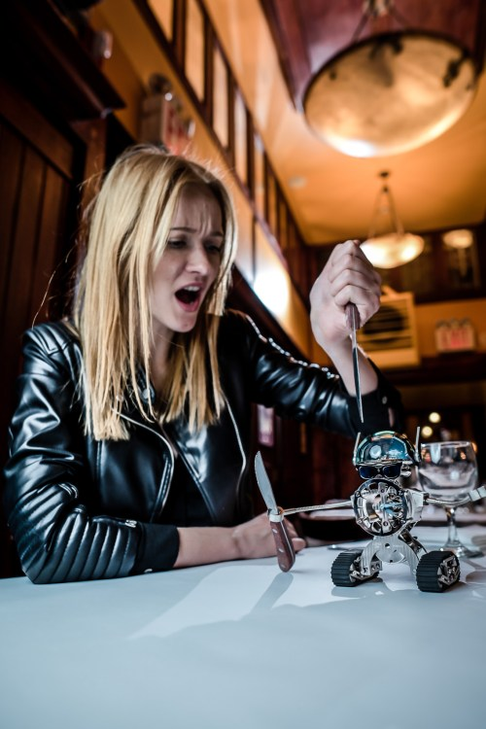
That’s not a knife…
This is Bad Sherman.
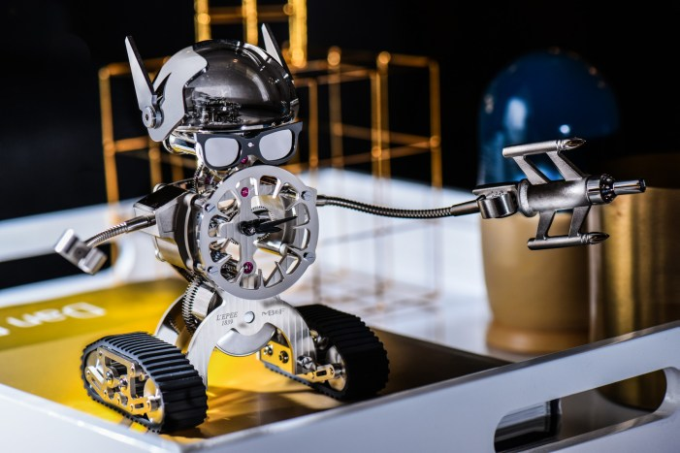

Bad Sherman isn’t just a misunderstood kid who got mixed up with the wrong crowd. He is the wrong crowd.
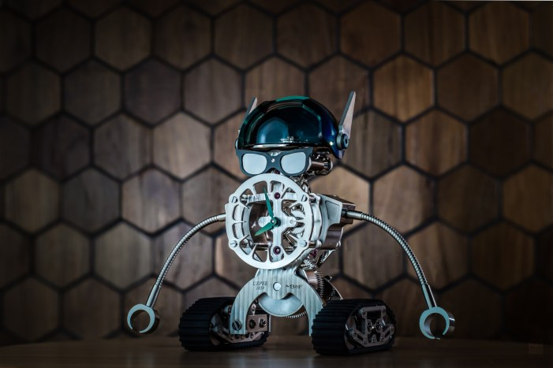
He’s the guy who always knows a guy. Whether you’re in Tijuana dive bars or Tokyo high rises, he can make things happen. Which is probably why him and Anish get on so well.
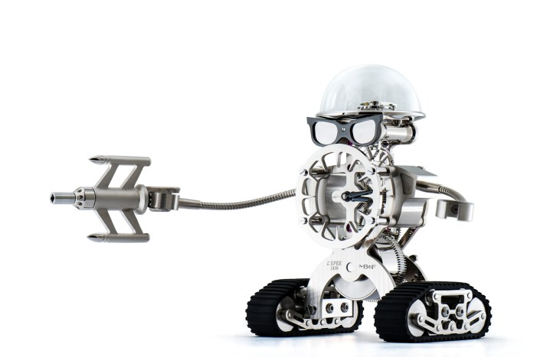

And this is your lucky day, because we have 3 different versions of Bad Sherman for sale, each limited to just 18 charming reprobates.
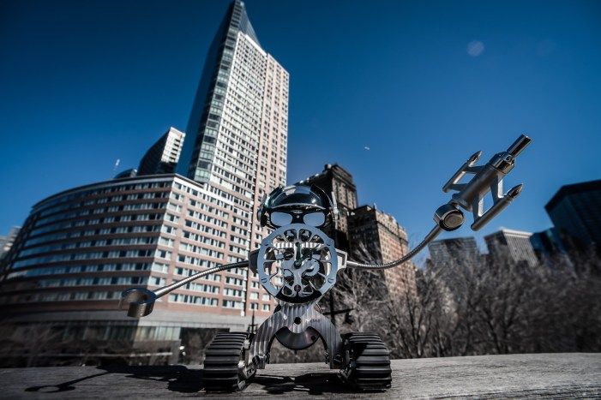
The cover of Bad Sherman’s debut album
You might meet these nuts-and-bolts bad asses all over the world, but you can only buy one here, exclusively at WatchAnish.com
Bad Sherman comes with a dapper removable hat for doffing to the ladies. A pair of sunglasses so you can’t see what he’s thinking while he plays high stakes poker in Monte Carlo, and a handgun that doubles as the clock-winder. He’s a timepiece that packs a piece, just in case.
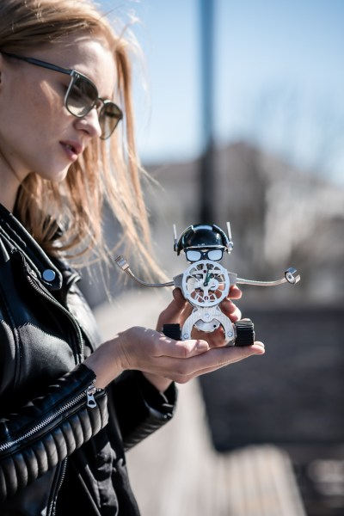
We’re happy to ship him to you anywhere in the world. He’s no stranger to false passports and the hostess in the first class cabin.
He’s a product of MB&F’s collaboration with L’Epee who have been at the forefront of clock production since 1839. Which was the year the first Daguerreotype photograph was exhibited, or the District of Columbia outlawed public dueling. Anyway, it’s way back in the day, and a hell of a long time to be doing something, which is why L’Epee are so damned good at making clocks, and now it transpires, robot objet d’art.
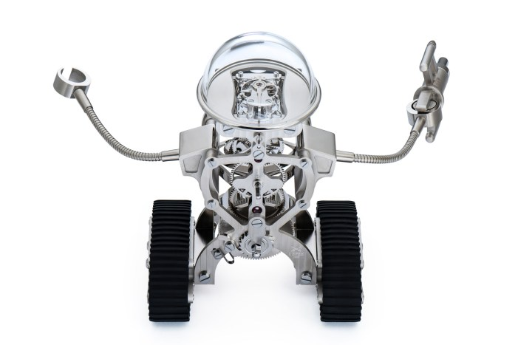
(This image is not a daguerreotype)
The idea stems from Maximilian Busser’s (he’s the MB in MB&F) childhood desire to own a robot. It’s a pretty twisted childhood that pines for a robot friend like Bad Sherman, but that’s Anish’s fault, not Maximilian’s!
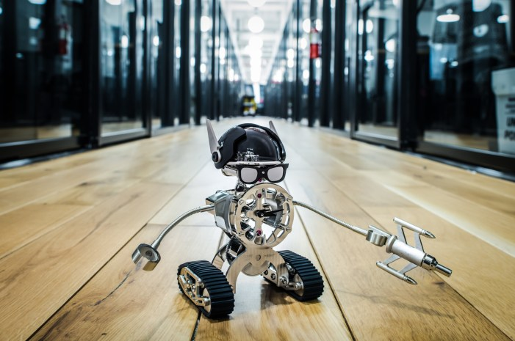
Bad Sherman giving us wood
The name is a nod towards the American Sherman Tank, and the caterpillar tracks that MB&F’s creation has. Point of historical interest, the Sherman tank was named by the Brits after Confederate general William Tecumseh Sherman. We can safely assume that as a Johnny Reb general, Sherman was probably the possessor of some impressively avant-garde facial hair, and a stylishly devil may care attitude. Which we think makes sense for our limited edition Watch Anish Bad Sherman’s.
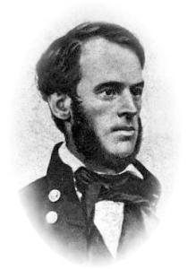
The original Sherman, great facial hair, not so good at telling the time

Vital Statistics:

8 DAYS POWER RESERVE
Sherman’s mechanics are based on a L’Epée in-line eight-day movement, which ensures that the friendly tank-treaded table clock can display the correct time for more than a week before rewinding.

CLOCK REGULATOR
The clock regulator’s gentle beating and intricate composition are made visible thanks to its polished glass dome cover. If the protective dome acts like a skull, then the regulator symbolises Sherman’s brain at work.

CATERPILLAR TRACKS
His rubber caterpillar tracks are fully functional and, with a little help from a friend, he can roll over the rugged terrain of a typical office desk.
Only Available here at Watch Anish
Photo Credit Petro Onysko

