**L’Epée 1839 Creative Art Residency**

**Presenting Unique creations highlighting the manufacture’s métiers and inspired artistic partnerships**

L’Epée 1839 draws inspiration from worlds as diverse as contemporary design, and various art forms. Today our manufacture unveils a new series of unique creations, highlighting its craftsmanship and daring creativity. Iconic pieces from its Creative Art line are reimagined through an artistic lens, each transformed into a one-of-a-kind work of art. Every Unique piece showcases either the manufacture’s full in-house expertise or its collaborations with talented artists. The result is a collection of kinetic sculptures that transcend artistic boundaries, blending craft and creativity into singular masterpieces — each with its own distinct personality, and feel, celebrating artistry and individuality.

Behind every creation is a team of designers, engineers, mechanics, and master watchmakers whose passion drive the manufacture forward. From development to the final assembly, each clock passes through the hands of these artisans, who combine centuries-old know-how with bold innovation. Their expertise ensures that every detail — from the beating heart of the movement to the gleaming surface finish — reflects the soul of true craftsmanship.

The manufacture has been a place of creative partnerships, embracing collaborations and exploring new territories, where in-house expertise and external artistry come together to enrich each creative piece. Driven by this spirit of co-creation and innovation, L’Epée 1839 continues to push the boundaries of horology, offering collectors pieces that are timeless, daring, and fused with artistic expression.

Renowned for its technical mastery, extra-long power reserves, impeccable finishing, playfulness and unexpected touches of humor, L’Epée 1839 has earned a reputation for turning clocks into extraordinary kinetic mechanical sculptures.

For more than 185 years, L’Epée 1839 has cultivated the art of high-end mechanical clockmaking. Today, it remains the only Swiss manufacture fully dedicated to mechanical clocks, preserving traditional savoir-faire while embracing innovation under one roof.

**L’Epée 1839 TF35 “Rust in Time” edition**

***Resident artist: Jeremy Brun***

In a bold and visionary collaboration, artist and in-house artisan Jeremy Brun reimagined the bodywork of the TF35 racing car, infusing it with an exquisite aged patina through masterful airbrush artistry. This exceptional project extends L’Epée 1839’s celebrated savoir-faire beyond the field of horology, translating the brand’s meticulous craftsmanship into an extraordinary and unexpected canvas—celebrating innovation, artistry, and timeless beauty in captivating new dimensions.

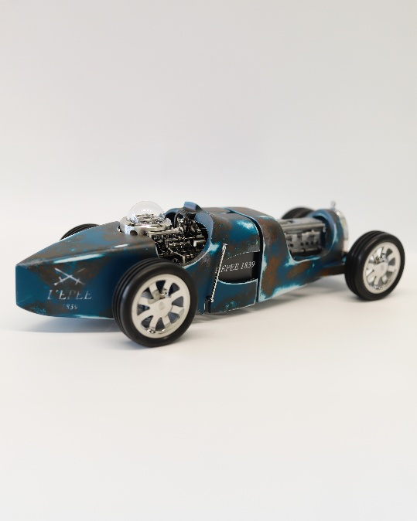 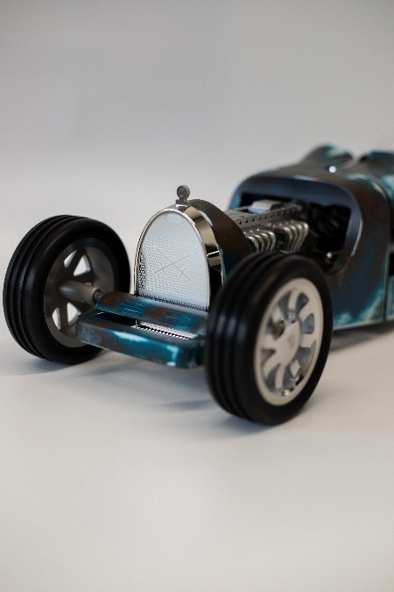

**About TF35**

Inspired by the legendary race cars of the 1920s and 1930s, the TF35 pays tribute to an icon of speed and engineering excellence. More than a kinetic sculpture, it is the ultimate gentleman’s accessory: a clock that discreetly displays the hours and minutes on its chassis while concealing a cigar torch within its V8-inspired engine, revealed by activating the handbrake.

Every detail recalls the golden age of racing—from the three-spoke steering wheel with its 12 rivets, used to set the time, to the cockpit beneath a glass dome showcasing the escapement. Powered by an in-house 8-day movement, the TF35 merges horological precision with the curves of its aluminum bodywork. Like the toy cars of our childhood, it is wound by turning the rear wheels—a playful nod to nostalgia and innovation in equal measure.

**About artist Jeremy Brun**

Jeremy has always been driven by a passion for automobiles and art, which he transformed into a career. Trained in decoration and painting, he spent over a decade working independently in the automotive industry, specializing in bespoke car designs and racing helmets, where he mastered the art of airbrush and custom decoration. He later brought his talent to horology, applying his expertise to the intricate painting of watch dials. Today, as part of the painting and decoration department at L’Epée 1839, Jeremy’s precision and creativity enrich every project, making him a valued artistic partner within the manufacture.

**Technical specifications**

Dimensions & Weight: 439.7 × 180.5 × 119 mm – 4.52 kg

Functions:

* Hours and minutes display
* Handbrake releases engine to reveal lighter
* Time set by turning the steering wheel counterclockwise (clockwise recenters it)
* Winding via rear wheels: pull back to wind barrel (car can move freely forward)

Movement : L’Epée 1839 in-house tiered mechanical movement, 8-day power reserve

Lighter : Rechargeable gas lighter with level indicator

Materials & Finishing : Palladium-plated brass, stainless steel, aluminum bodywork with automotive lacquer, blown glass dome (driver’s helmet effect), stainless steel rims